Appendices

Appendix A: Sample Outreach Email to School Officials 32

Appendix B: Funding Voter Registration Drives 33

Appendix C: Registration Drive Checklist 34

Appendix D: Coalition-Building Strategies 37

Appendix E: Sample Work Plan 41

Appendix F: Using Online Voter Registration at Events 48

Appendix G: A Script for Talking with Young Voters 50

Appendix H: Media Talking Points about Young Voters 52

Appendix I: Sample Social Media Posts 53

Appendix J: Sample Press Release 55

Appendix K: Sample Letter to the Editor 56

Appendix L: Sample Get-out-the-Vote Scripts (phone/email) 57

Appendix M: Sample Registration Activity Worksheet to Quantify Results 59

Appendix N: Printable Voter Pledge Cards 60

Appendix O: Printable Sign in Sheet 61

Appendix P: Printable Flyer 62

Appendix Q:Printable VOTE411.org Postcards 63

Appendix A: Sample Outreach Email to School Official(s)
Dear [Principal/Lead Teacher/Administrator],
On behalf of the [your organization’s name], I would like to offer [SCHOOL or SCHOOLs in XX DISTRICT] our services to help your students register to vote. With nearly 100 years of experience dedicated to expanding and protecting civic engagement, we would like to work with you to build voter registration into your current curriculum.
Each year, Leagues all over the country work closely with schools to reach and build empowered student voters to create a stronger democracy, and you can help us.
Our [volunteers/ staff members]:
- Set up class or homeroom visits to talk about the importance of voting,
- Make sure students know their rights,
- Assist eligible students in filling out their registration forms,
- Collect all registration forms, and then deliver them to the appropriate elections officials.
If such visits are not possible, we are open to scheduling a voter registration assembly or visiting during lunch periods. Although, we urge you to prioritize classroom visits as national research by the League of Women Voters has shown it is by far the most efficient and effective method of conducting high school voter registration.
From the economy to the future of their education and the safety of our neighborhoods, young people have a critical role to play in shaping important issues in our community and across the nation. We would be thrilled to work with you to help them register and vote this year.
Thank you for your time, and I look forward to speaking with you soon.
Sincerely,
[CONTACT INFO]

Needed Items | General Costs*
“Register to Vote” signs and/or organizational banners | $200-$600 for several
Interns or part-time staff member to coordinate elections work | $1,000-$2,000/semester
Reminder postcard or other educational handouts about Election Day and voting hours/rules (+postage) | $200-$500
Translation work for voter education materials | $400 (dependent on project)
Technical assistance for publicity, voters’ guide, etc. | $100/hour
Newspaper/radio ads | $200-$1000 per ad buy
Billboard rentals to draw attention to key voter info | $1500/rental
Portable printers/iPads for voter registration events | $100-$5,000
Table & tents for events | $300-$600
Mileage for volunteers (IRS rate for charitable organizations) | $0.14/mile
Overhead/indirect costs for office rent, phone use, etc. that supports election programs | 10% of program costs
Refreshments for voter registration and education events | $10-$20/event
Printed training guides & refreshments for voter registration partners/ volunteer trainings | $200/training
Post-Election volunteer appreciation parties | $250- $500
Appendix B: Funding Voter Registration Drives

Based on feedback from League volunteers from across the country, we have compiled these guidelines for estimating costs for your voter registration work.
*Costs vary widely by location and breadth of program
Appendix C: Registration Drive Checklist

Use this checklist to stay on top of every detail of your voter registration drive.

Befriend Local Experts
- Coordinate with organizations already doing voter registration in your community.
- Touch base with local elections officials to let them know your plans, pick up blank forms, and attend any offered trainings.

Pick the Right Venue
- Aim to reach lots of people, especially those who might not be already registered to vote.
- Great locations include:
  - High schools, community colleges, technical schools
  - Individual classrooms
  - School/sporting events
  - Senior events

Know the Law and Take Time to Train
- Voter registration rules differ from place to place, so make sure your volunteers are familiar with the federal and state laws that govern voter registration in your community. For more information, contact your local elections official or check out http://fairelectionsnetwork.com/resources.
- Be sure to keep registration drives nonpartisan, and take the time to practice your registration “pitch” with volunteers.
A positive and enthusiastic attitude is the way to win over potential new voters.

Plan Ahead

Assign a volunteer or event leader to bring the following items to your event:
- Voter registration forms, clipboards, and collection envelope
- If applicable in your state, equipment to offer online voter registration (you can use VOTE411.org)
- Banner and signs, including “REGISTER TO VOTE HERE” sign
- Pencils and pens
- Information on/applications for absentee voting & other voting details for your state (visit VOTE411.org for help)
- Sign-up sheets or pledge cards for voters to keep in touch with your group
- Extra forms for newly registered voters to share with their friends and family

Publicize!
- Reach out to your social networks and local media to let them know when and where you’ll be registering voters.
- If you’re able to reach out to potential registrants (such as at a school) ahead of time, alert them to any identification info required on your state’s voter registration form (such as a driver’s license number or social security number)
- After your event, report the results to your networks and local media, and THANK your volunteers!

At the Event
- Work the crowd.
- Have a clear plan for how you’ll collect and return completed registration applications to the required elections official, being sure to follow any state requirements.
- Have enough volunteers. While one person talks, others can assist individuals, collect forms, and help echo important messages!
- Quickly check all forms for completion. In particular, check to see that registrants have:
  - Checked the box affirming they are over 18 (unless pre-registering).
  - Checked the box affirming they are a US citizen.
  - Provided any required identification number, usually their driver’s license number or some or all digits of their social security number.
  - Signed and dated the form.
- Follow any and all rules regarding voter registration drives in your state.

Follow Up
- Keep track of the names, addresses and telephone numbers of everyone you register by creating a spreadsheet or by photocopying registration cards, where permissible by law. You can also ask them to fill out a sign-up sheet or pledge card to receive election reminders from you.
- This information is key to following up with voters to provide helpful information about voting, and will also help your team maintain accurate records about your voter registration drives.
- Closer to election day, help get the new registrants out to vote by directing them to polling place or other critical election information (such as on VOTE411.org)

Appendix D: Coalition-building Strategies

This coalition-building planning tool will help you identify and recruit allies, set out goals and priorities, and build a strong foundation for collective success. Whether your organization is just starting out or already participates in a longstanding coalition, it is worth taking a moment to assess your collective strengths and better plan for the future.
Why Coalitions?
Coalitions are created to bring about collective action at the national, state or local level. Many organizations work in coalitions on a broad range of issues for years, or on specific programs or priorities for a short period of time. Whatever the purpose, coalition efforts can help maximize groups’ effectiveness by:
- Empowering organizations to pool resources and brainpower to foster more strategic and effective action,
- Enabling better communication and collaboration between like-minded organizations,
- Increasing diversity by bringing together new or alternative voices, and by
- Bringing about a greater impact than organizations could make on their own.

Getting Started: Recruit Allies
For voter registration purposes, consider forming partnerships with organizations such as the following:
- Civil rights leaders, including members of the disability community
- Academics, student groups, PTAs and school boards
- Civic/Democracy groups

As you identify potential new partners, keep in mind that nontraditional alliances or highly visible bipartisan efforts often gain attention and respect from the public, the media, and key stakeholders.
Considerations when recruiting allies

Building your Registration Campaign

Set Goals. What are the top three things you want to achieve? What will “success” look like for the coalition? Articulating these goals, and keeping your mission very focused, are critical first steps toward establishing a successful coalition.

Remember, the purpose of this initiative is to increase youth voter engagement, particularly those who are most often left out of democracy.

Identify assets and needs. What does the group have or need to achieve its goals? Coalition members may have great school connections, but lack tools for reaching out to key media. You may have access to coalition funding, but no staff to coordinate activities. Use this guide to map our your coalition assets and needs.

Appendix E: Sample Work Plan

This work plan will help you stay on track from the planning stages of your registration program through the very end. Remember: our research shows that mid-spring is the best time to do high school voter registration.
At a Glance: High School Voter Registration Event Planning Timeline

*Keep this in mind: During LWVEF’s 2010 High School registration project, volunteer teams reported <50% of schools contacted scheduled registration events.

Leagues collected completed registration applications from approximately three out of every ten students they encountered during classroom visits. These numbers tend to go up when Leagues make repeat school visits; long term relationship building means more schools participate and the process works better each time.

Four months out:
Determine project goals and leadership
THINK!
How will you target underrepresented populations?

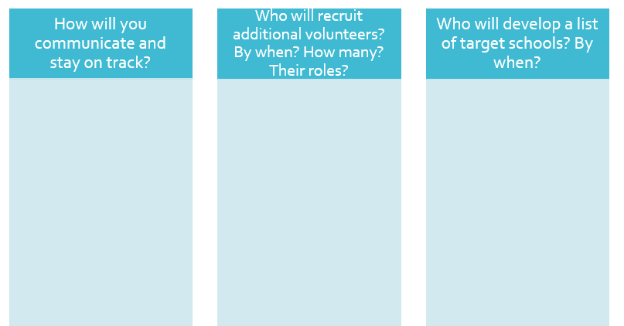
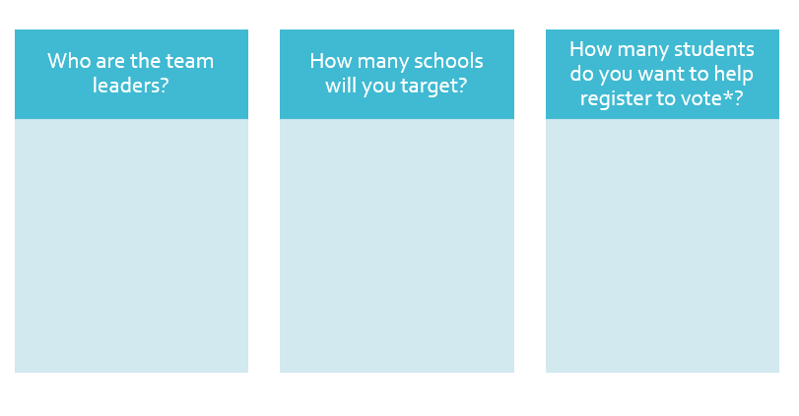

Two/three months out: School outreach and assigning team roles

Get Organized: Once you have recruited additional helpers and developed a list of target schools, pull together your entire team to get organized and assign roles. Use these charts as a guide, or consider setting up a Google Doc or other method for regularly updating and sharing the results of your efforts.

School Outreach: Who will call or write the schools to ask them about setting up a registration program? How often will they follow up? Does anyone know of a good contact to try first?

School Name | Team Member Responsible | Initial contact made? With who? When? | Who is following up? | Drive scheduled? When?

Additional roles to assign

One month out: Team training

As your activities approach, hold a training for everyone who will be visiting schools and/or handling registration forms. This is a good idea whether or not training is required by your elections officials.

At the training:

- Assign additional school outreach as needed

- Practice walking through the registration form or online registration system for your state/available through VOTE411.org. State the eligibility requirements and remind students that they are legally obligated to provide truthful information, but that no one is required to fill out the form and may opt out of doing so if they choose.

- Ask team members to practice their voter registration pitch aloud!

- Review registration event activity forms.

- Anticipate likely questions you will hear from students and practice how you will handle sensitive issues (non-eligible students, questions about partisan issues, etc.).

- Provide a timeline and process for handling completed registration forms, including:
  - What form turnaround time, if any, is required by state law
  - Which members of your team are responsible for handling completed forms.
  - Your plan for collecting registrants’ contact information and following up with them with additional voting-related information.

- Motivate your team for the busy work ahead!

One/two weeks out: Final preparations

In the final days before your registration events, check in with each team member to clarify their roles during the event, and assign a person to bring each of the following:

Day of the Event and Beyond

During the registration event, designate one person to serve as the “spokesperson” and additional people to serve as “helpers”. Helpers can walk from desk to desk to answer students’ questions or otherwise support the spokesperson. Designate a “collector” to gather all completed applications forms and record the results of each event.

Post-event

- Data Collection: After the event, follow your plan for collecting data from the completed application forms (as allowed by state law) and return all completed registration forms to the appropriate official in the timeline set by your state.

- Follow-up: Next, begin planning your follow-up communications with the newly registered voters, urging them to learn more about the elections process and reminding them to vote.

- Say Thanks: Finally, follow up with a quick, timely note to thank school teachers/administrators for their time. This will go a long way toward establishing a fruitful relationship in the future!

Post-campaign

- Visibility: After all your registration events have wrapped up, work with the individual designated earlier to get the word out to the public and the media about your impact.

- Evaluation: Evaluate your program and learn about how to improve future efforts. Ask your team what could have been done better and start thinking about your planning process for next semester.

- Follow up with your elections officials to determine how many of your registrants successfully made it onto the voter rolls and/or turned out to vote.

- Celebrate: Thank your team, publicly if possible, and take some time to celebrate your successes!

Appendix F: Using Online Voter Registration at Events
With an increasing number of states adopting online voter registration portals in recent years, community organizations like the League of Women Voters are taking advantage of widely available technology to help voters complete the registration process on the spot at community events, in schools, and on their way to work. Online voter registration reduces costs and streamlines the administrative burden on voters, those of us who serve them and local elections officials. It can dramatically increase the number of voter registration applications that are successfully processed by local elections officials. At the same time, it raises new questions about how best to deploy technology for maximum effect.
Consider these questions if your group is planning to use online registration voter registration at a community event:
- Does the venue and expected volume of people make sense for online tools?
- Is your location WiFi enabled? Can it reliably handle multiple devices at once?
- Do you have enough tablets/computers/smartphones to handle the potential demand for voter registration?
For example: a crowded classroom with only one available computer is probably NOT a great fit for an online voter registration experiment. But how about a school where every student is equipped with a device? Or heading to an event with five volunteers, each equipped with a compatible device?
- Will the screen of your devices be visible in bright sunlight (if outside)? If not, does your League have a tent or a shadier option?
- How mobile-friendly is the online tool? Does your state’s tool work completely and efficiently on various devices, or only on a desktop computer? Test it out ahead of time!
HINT- VOTE411.org’s online registration tool IS mobile-friendly and works in every state where online registration is offered. In states without online registration, the system will email a print-ready PDF to registrants to print and mail in themselves.
- How inclusive is the online tool?
In some states, online voter registration tools currently only accept applicants who possess a current state driver’s license and/or a learner’s permit; thus, many potential voters may not be able to use the online tool and will instead need a traditional paper form or a tool like the one available at www.vote411.org/register (see below).
- How comfortable are your volunteers with the online tool?
As you would before any voter registration drive, make sure your team takes some time to practice using the online registration system to ensure your volunteers are comfortable answering questions and navigating the technology.
- How will you follow-up with voters?
Can you ask registrants to “Like” your Facebook page (or ask them to “Like” the League’s VOTE411 Facebook page) on the spot? Fill out a sign-up sheet to receive emails from you? Hand out educational materials including your contact information? All of these go a long way toward ensuring voters have the information they need to participate. Please note: new voters should only be contacted about election information unless they have specifically signed up to receive other kinds of information from you (such as fundraising emails or action alerts).

Key Reminders:
- Review the rules governing voter registration drives in your state. Contact LWVUS if you need help. If you are using paper forms in addition to online technology to help voter register, be mindful of any requirements to turn in forms in a certain timeframe.

- Remember: voters may need to use a paper form if they do not have the identification required by your state’s online tool, or if they do not have an active email address. ASK if they have the required identification and an email address before they start the process.

- As an alternative to your state’s online portal, consider promoting the League’s national online voter registration tool at www.VOTE411.org/register, which provides a mobile-friendly platform for voters from any state to fill out a voter registration form online. In most states, the system will automatically pass registrants on to their state’s online voter registration portal to complete the process. In states without online registration, the system will generate an email to the voter with a PDF of a voter’s completed voter registration application, which they must print, sign and mail in to the elections official. This option could work well if your state does not have an online voter registration system that is available to all voters (including those without a driver’s license) as well as at events where a printer will be available.

- Always ensure you have an adequate supply of back-up paper registration forms (or comfort using the www.VOTE411.org/register tool) should any logistical or technological challenge arise.

- Remain flexible. You’ll no doubt think of newer, better ways to deploy online technology as you go. Stay flexible and open to suggestions from your “front line” of volunteers.

- Be mindful of any restrictions on providing assistance to registrants. In some states, there may be restrictions on voter registration volunteers directly assisting voters in filling out an online form (for example, typing in the information for someone who is unfamiliar using mobile technology). In that case, it may be more appropriate to provide a paper form to the voter and provide instructions on filling it out.
- Stand by to help. Volunteers should help voters navigate the system.
Appendix G: A Script for Talking with Young Voters

Walk into your registration event with a clear plan for inspiring your young audience to know their rights and get registered to vote.

Why vote?

- Voting is our chance to take control over what happens to us, our families, and our community.
- Ask the group: Why do you think it’s important to vote? Who here has registered or voted already? If so, why did you do it?
- Do you care about: Keeping crime low in your neighborhood? Job opportunities and health care for your family & friends? Every single one of those things, and so many more, are decided by our elected officials (the people who run your school board, work in city hall and represent you in Congress). They are making decisions every day that impact your life. Voting is our chance to have a say.
- Voting brings us all together as proud Americans. It’s one time whether you’re young or old, rich or poor, that we all have the same say.
- America’s future is our future. We must elect leaders who will lift up our communities and make them better.
- We can’t complain about the way things are going if we don’t stand up for what we believe in and what we want.

How does it work?

These points will vary by state, but these are the basic messages to convey to students as you hand out voter registration forms:

- If you are a U.S. citizen and will be at least 18 years old by [the next federal election date], you are eligible to register to vote.
- Provide any state-specific pre-registration options for 16 or 17 year-old voters.
- In most states, you MUST register to vote before participating in an election (30 days, 2 weeks, etc. before Election Day).
- We’re making that easy for you to do today. By filling out these forms and having us turn them in for you at the [Board of Elections, County elections office], you’re taking a first step toward having a say in our democracy.
- Once you fill out the application form, you should receive confirmation by mail within a few weeks. If you have questions, you can contact your local elections office or the organization holding this drive (have necessary contact information on-hand for students).
- Whether you’ll be voting in person or absentee this election, it’s easy and important to learn about the candidates running for office and find out what to do on Election Day. We’ll be following up with you with the basic information you’ll need on Election Day.
- Most likely, you’ll have several choices to make when you vote. For example, this year you’ll vote for [Senate, Governor, members of Congress, mayor and school board]. You may also be asked to vote on other things, like money for schools or roads, and whether you approve of certain laws.
- Visit VOTE411.org for more information, or go to (local League site or other resource).
- Every voter deserves to be treated fairly. You have rights at the polling place! This includes:
  - Equal treatment and opportunity to register and vote, regardless of race, religion, national origin, sex or disability.
  - Privacy—only you should know how you voted.
  - Having your vote accurately recorded and counted.
  - If you have a disability, access to a voting device you can use and appropriate assistance.
  - Assistance from poll workers on how to use the voting equipment if you request it.
  - Courtesy from poll workers and others at the polling place.

Tips for youth registration:

- Partner with a student group. Research shows: Peer-to-peer voter engagement works!

- Keep it relevant and personal. Tie voting to a hot issue in the community and frame it in a way that speaks to results. Has the school budget recently been cut? Is a highway being built through the center of students’ neighborhoods? Chances are the students have an opinion.

- Tie it to something in the classroom. Find out what issues or trends they are discussing in the classroom and weave it into your discussion of current events and the importance of voting.

- Keep it brief and interactive. While you want to use your speaking opportunity to tell the students a little about your organization and discuss the importance of voting, it is important to keep your remarks brief and interesting. Kick things off by asking students why they think voting is important, and allow them time to ask questions about completing their form. Students and teachers are pressed for time—make the most of it!

- Study up on voting rules in your state. Be prepared for questions regarding the registration and voting process, especially absentee voting and preregistration in your state. Help any students in need of assistance and be sure to look over their registration forms to ensure they are complete.

Appendix H: Media Talking Points about Young Voters

Utilize these talking points to prepare for media interviews, public appearances, or even internal questions about the importance of reaching young voters.

Who are young voters?

- The Millennial and Gen Z generations are large, diverse, tolerant, civically engaged and optimistic. More than almost any other group, they are enthusiastic about voting but need helpful, accurate and timely information in order to exercise their right.
- Young people are involved in their local communities. Generation Z students are motivated by volunteer opportunities that aim to address large social problems, rather than one off service opportunities.
- Young people are leading social movements, volunteering in their communities, and are civically engaged at all-time high rates.
- Young voters are more diverse than other age groups. Young voters (age 18-29) were more diverse than older voters according to 2016 exit polls.

Do young people vote?

- Young people register and vote at levels lower than the overall population, but research has shown that they turn out more when elections are competitive, when voter-friendly options are in place in their state (especially same-day voter registration), and when they are explicitly ASKED to register and vote.
- Eighty-four percent of young people believe their generation has the power to change our country.
- An estimated 24 million young Americans under the age of 30 voted in the 2016 presidential election, representing 46.1% turnout among eligible young people.
- It is especially important to reach young people who do not attend college. Those with no college experience vote significantly less than youth overall.
- Turnout among young voters contacted by nonprofits was 5.7 percentage points HIGHER than those who were not contacted.

The lesson here is that when candidates and elected officials talk, young people listen. It is critical for us to engage young voters in our community and provide them with meaningful opportunities to get involved. One way to do this is through voter registration at the high school level.

*Analysis by CIRCLE (https://civicyouth.org/full-analysis-young-voters-in-the-2016-general-election/ and https://civicyouth.org/an-estimated-24-million-young-people-vote-in-2016-election/) and Harvard Kennedy School (http://www.iop.harvard.edu/survey/details/harvard-iop-fall-2015-poll)

Appendix I: Sample Social Media Posts

Social media has revolutionized public political engagement. Thanks to these tools, it is easier than ever to build and sustain engagement on important issues. While there are many social media tools, we will focus on the four social media platforms predominately used by young people today. Tailor messages to fit your community and learn more from the League’s Social Media Toolkit.
Photo-focused social media:

- SnapChat is a mobile messaging app used to share moments through photos, videos and texts. It can be a helpful marketing tool for voter registration events. Young people are influenced by their peers and by encouraging the students you come across who register to share their experiences through SnapChat, they will be helping spread the word about your registration event and what it means to be an empowered voter.

- Instagram is a photo and video-sharing social networking service. Similar to SnapChat, people use Instagram to post videos or pictures of themselves experiencing important moments.

Through SnapChat and Instagram’s ‘story’ and ‘live’ functions, registration participants can share their excitement about voter registration with their community in real time.

Make events photo-friendly! Filters are functions associated within SnapChat that allow individuals to enhance their pictures. For a minimal cost (0-$3), you can purchase a geo-located SnapChat ‘filter’ that allows you to highlight your event and attract further participation.

Information sharing and public education focused platforms:

- Facebook is a widely used social media platform and is a great way to advertise your efforts ahead of any event where you will be registering young voters. You can build an event page, post pictures, and post related news articles. After your efforts, you can post pictures with a succinct message reflecting on the event and what it meant to the people you registered.
Sample posts
Today, we are preparing our teams of volunteers to register and empower young people to vote. Young people are leading the way toward a democracy that works better for all Americans! [Insert relevant picture]

Elections are the heart of our democracy. Engaging students by registering them to vote is just one of the many ways the League of Women Voters of [LEAGUE NAME] serve and protect democracy in our country. We are honored to be able to register new voters.

The League of Women Voters is the largest voter registration group nationwide. We are excited to keep up those efforts this year by engaging the new generation through voter registration events!

- Twitter is an online news and social networking service on which users post and interact with messages known as "tweets". Most posts must be within 140 characters, but it is a great way to share and advertise League related news. Samples:

Sample tweets
LWV of [STATE/COUNTY/CITY]’s team is spending today empowering young people by registering them to vote at [SCHOOL] ! #voting

Our democracy is about citizens’ voices! League of Women Voters of [STATE/COUNTY/CITY] loves registering young people to vote.

Hashtags enhance the social media and networking experience. Compelling hashtags (ie #voting #empoweredvoters) allow people to take and share their voter registration experience with their friends and feel part of a broader movement. They can be used within any of your social media posts, and you can encourage those you come across to use your hashtag when they make their own posts through Facebook, Twitter, Instagram, and SnapChat.

Appendix J: Sample Press Release

Use this press release to send a customized message to media in your area. Be sure to include tangible facts about the success of your registration program!

FOR IMMEDIATE RELEASE CONTACT:[NAME] [DATE] [PHONE, EMAIL]

YOUNG VOTERS ARE KEY TO UPCOMING ELECTIONS
[LOCAL ORGANIZATION NAME] Registers [XX] High School Students to Vote

[TOWN, DATE]- [LOCAL ORGANIZATION] members recently registered [XX] students at [XX] local high schools to vote, according to a statement released today by [SPOKESPERSON].

“We’re thrilled to have worked with the dedicated faculty and students at [HIGH SCHOOL NAME(s)] to make sure all newly eligible voters know their rights and have the opportunity to play a critical role in our community’s future,” said [SPOKESPERSON’S NAME]. “We can’t wait to see them at the polls in November.”

From strengthening the economy to building safer communities and making education more affordable, young people are building a stronger America. This year, [ORGANIZATION] is taking advantage of that energy by helping students register to vote for the first time.

“Students were excited to have the opportunity to participate in the upcoming election,” said [SPOKESPERSON]. “For example, one young man/woman [provide interesting anecdote or quote from student about why they are registering to vote here].”

Young people are an increasingly influential part of the electorate. In 2016, Americans under 30 represented almost a quarter of the overall American electorate, yet nearly half did not vote. Exit polling has shown that young people participate in significantly larger numbers when they are directly contacted by an organization or have the opportunity to interact with candidates for office.

“From the president and Congress, all the way down to our local school boards, our elected officials have incredible influence over the issues and policies that affect our families and communities most. Election Day is our chance to weigh in and take control over what is most important to us,” said [SPOKESPERSON].

For more information about registering to vote or getting involved in [ORGANIZATION’s] work, visit [YOUR WEBSITE].

Appendix K: Sample Letter to the Editor

Customize this sample Letter to the Editor to submit to your local newspaper(s). Doing so will help publicize your efforts and expertise and elevate your organization within the community.

Young Voters Key to the Future of Our Democracy

To the Editor,

Every passing day brings renewed debate about the future of our economy, the fate of health care and education, and our place in the world [If possible, refer to a recent article written on a public policy issue & include publication date]. Too often lost in the shuffle of partisan politics is the reminder that each one of us has an equal say in influencing our future.

[Today, this week, last Thursday, etc.], an active debate was underway, not in the halls of Congress or City Hall [or other local government seat], but in the [12th grade history class/auditorium] at [High School name]. Together with [ORGANIZATION], I had the opportunity to talk with students about why their voice is needed on Election Day and throughout the year. As [18]-year-old student [NAME] told us, “[reason why registering/why voting here is important].”

Now more than ever, our community’s young people want to be a part of the solution to the challenges we face. Their future depends on it. Thank you to [Student NAME from Above] and all [School name] students who took a stand and registered to vote. I hope readers will do the same.

[NAME]
[TITLE]
[ORGANIZATION]

Appendix L: Sample Get-out-the-vote Email and Phone Scripts

Sample GOTV Email Script:
Subject Line: Important Information before you Vote
(Best if sent personally and/or in a mail merge with at least the first name of the recipient customized).

Hi [NAME],

Election Day is almost here! Are you ready to vote?

You may remember that we helped you register to vote at [venue/your school] back in [September/October]. Now we’re reaching out to share some important tips for Election Day.

This may be the most important election of our lifetime. Election Day, [November X], is your chance to take control for your community and weigh in on the issues that matter most to you and your family. As voters, we all have an equal say in determining our future. That’s why it is so important to go cast a vote!

Here are a few important tips:
- If you need to find information about how, when and where to vote, please visit www.VOTE411.org and enter your address.
- On Election Day, polling places are open in from XX am to XX pm.
- [IF required in your state] At the polls, you’ll be required to show [an ID/utility bill/etc.].

The leaders we elect will make decisions that affect your everyday life — your job, health care, energy costs, the economy and more. So don't sit this one out — join your friends and neighbors and make it count on [DATE]!

If we can help answer any questions you have about the election process, please feel free to contact us at [LEAGUE or YOUR ORG CONTACT INFO]

Thank you for voting!

YOUR NAME
YOUR ORGANIZATION

PS- Sign up to learn more about the League of Women Voters or YOUR ORG by [joining us on Facebook/signing up for our newsletter, etc.].

Sample GOTV Phone Script
(Best if made starting a few days before or up until the night before the Election)

Hello, is [VOTER NAME] there?

Hi! This is [CALLER NAME] calling from the League of Women Voters of XX or YOUR ORG.

We helped you register to vote at [venue/your school] back in [September/October].

We wanted to thank you again for registering and wanted to remind you about the election on [DATE].

Can we count on you to go vote on [DATE]?

IF YES:
Great! We’ve been calling other voters and it sounds like a lot of people in [COMMUNITY] will be voting this year. It’s an important election, and we’re so excited that you’ll have the chance to stand up for our community by casting a vote. Can I remind you of your polling place [you can most likely look it up on VOTE411.org or your Secretary of State’s site]?
Do you know when you might go to vote on Tuesday? In the morning, afternoon, evening? Do you have a plan for getting there?

IF NO/MAYBE:
OK, what other information can I provide to you to help make voting a little easier? I’d be happy to tell you a little more about what to expect at the polls [have polling place hours, required ID info handy].
----

Can I answer any questions about voting?

Great! Again, thank you for your promise to vote this year.

Appendix M: Sample Registration Activity Worksheet to Quantify Results

BASIC ACTIVITY INFORMATION

School Name: Length of Activity (in hours)

Date of Activity:

Type of Activity (tabling, classroom visits, assembly, etc.):

Total Number of Volunteers/staff:

Approximate Cost of Event:

BENCHMARKS OF SUCCESS

Total Number of Participating Students:

Total Number of Registration Forms Distributed:

Total Number of Completed Registration Applications Collected:

Total Number of Applications Taken Home/Left Behind at School:

Total Number of Pledge Cards/Sign-ups Collected:

Approximate Number of Educational Materials Distributed:

Appendix N: Printable Voter Pledge Cards

Print and cut out these cards to collect student information and motivate them to vote.

I will vote this Election Day to stand up for what matters most to me, my family and my community.
I, pledge to vote this year.
Please send me reminders about upcoming elections: Email:
Cell:

I will vote this Election Day to stand up for what matters most to me, my family and my community.
I, pledge to vote this year.
Please send me reminders about upcoming elections: Email:
Cell:

I will vote this Election Day to stand up for what matters most to me, my family and my community.
I, pledge to vote this year.
Please send me reminders about upcoming elections: Email:
Cell:

Appendix O: Sample Sign-In Sheet
Sign Up to Receive Helpful Election Information from [YOUR GROUP]
Name | Email | Phone

Appendix P: Printable Flyer

Customize this flyer and ask school officials to post it prominently on the day(s) preceding your registration event.
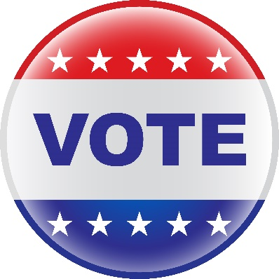
UPCOMING VOTER REGISTRATION DRIVE
What? | The opportunity to Make your voice heard!  [Organization] will help eligible voters register to vote
When? | [DAY]
Where? | XX Room during XX period/time
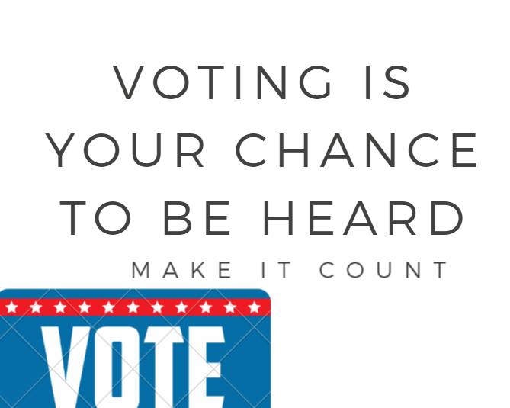
*In order to register to vote, you must be at least18 years old by [DATE] as determined by state law.

DON’T FORGET! Bring your driver’s license/social security number to the event!

[YOUR LOGO HERE]

Appendix Q: VOTE411.org Printable Cards

Access a printable VOTE411.org flyer here
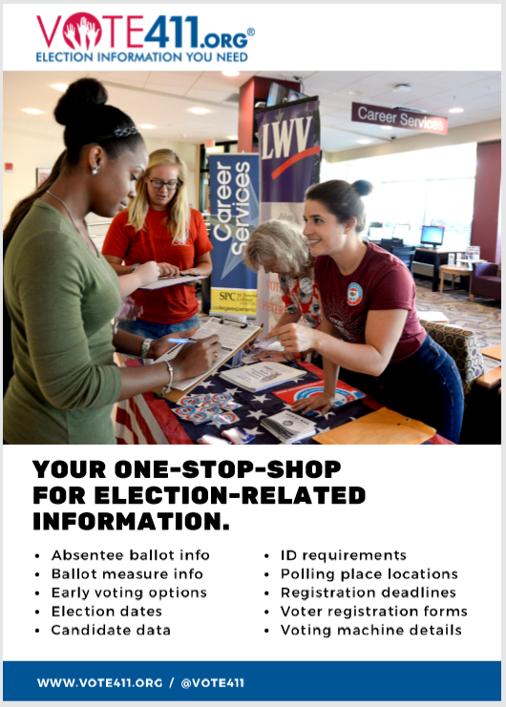

Making Democracy Work
TM

The League of Women Voters encourages informed and active participation in government, works to increase understanding of major public policy issues and influences public policy through education and advocacy.

Membership in the League is open to women and men of all ages. With nearly 800 state and local affiliates nationwide, the League is where hands-on work to safeguard democracy leads to civic improvement!

Join us in Making Democracy Work™!

League of Women Voters Education Fund
1730 M Street, NW Suite 1000
Washington, DC 20036
202-429-1965
www.lwv.org
Facebook | Twitter

