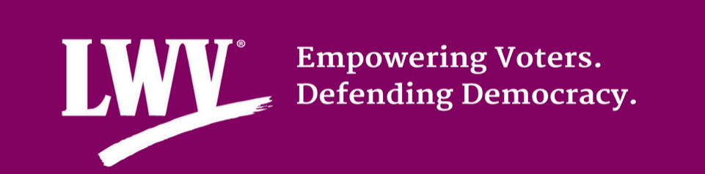
FOR IMMEDIATE RELEASE  July XX, 2018 | Contact: NAME  Phone: NUMBER  Email: ADDRESS

League of Women Voters of [LOCAL/STATE] Returns from National Convention
League Affirms Commitment to Voting Rights in Midterm Election Year
CITY, State – The League of Women Voters of [LEAGUE NAME] was represented by [INDIVIDUAL NAME(s)] at the League of Women Voters of the United States (LWVUS) 53rd National Convention held June 28 – July 1 in Chicago, IL. More than 1,000 League leaders from 49 states and the District of Columbia attended leadership workshops and heard from guest speakers about League priorities.
“We all want to see a League of Women Voters that’s suited to meet 21st-century demands, that works hard to court a new generation of leaders and activists, that looks like the people and communities for whom we so fervently advocate,” said Chris Carson, LWVUS president in her opening remarks to the Convention delegates and attendees.
Founded in Chicago in 1920, the League of Women Voters is active in all 50 states with more than 750 chapters across the country.
“Convention was an incredible opportunity to connect with and learn from League leaders who are actively working in their communities to empower voters and defend democracy,” said [INDIVIDUAL NAME, affiliation with LEAGE NAME].
[INSERT PERSONAL EXPERIENCES HERE]
The Convention kicked off with A Conversation on Redistricting where attendees heard from Ruth Greenwood and Nick Stephanopoulos. Greenwood served on the legal team for the plaintiffs in the United States Supreme Court case Gill v. Whitford which the Court decided in June.
“Partisan and racial gerrymandering is a huge problem in this country, and the League is fighting to make sure the voters elect politicians who truly represent their interests, rather than elected officials picking their constituents,” said [INDIVIDUAL NAME, affiliation with LEAGE NAME]. “In [local community or state] the League is fighting back by [insert local action on redistricting if applicable here].”
Over the four-day Convention, delegates voted on the priorities that the national organization should focus on for the next biennium. The Campaign for Making Democracy Work® includes ensuring a free, fair, and accessible electoral system for all eligible voters by focusing on Voting Rights, Improving Elections, and advocacy for the National Popular Vote Compact, Campaign Finance/Money in Politics, and Redistricting.
The final night of Convention, attendees heard from Elaine Weiss, author of the Women’s Hour at a banquet where Leagues were recognized with awards for their work on XXX. [INSERT ANY LOCAL / STATE REFRENCE OF NOMINEES OR WINNERS HERE.]
“Hearing Elaine Weiss recount the final push for women’s suffrage in this country reminded me how important the League of Women Voters is to this day,” said [INIVIDUAL NAME]. “The number of women in elected offices do not reflect the demographic makeup of women in our communities. This is an important midterm election year and the League is committed to making sure the voters in [local area or state] have the resources they need to participate in November.”
###

Find us online: Facebook | Twitter | Instagram
The League of Women Voters envisions a democracy where every person has the desire, the right, the knowledge and the confidence to participate. We believe in the power of women to create a more perfect democracy.

