Printable Voter Pledge Cards

Print and cut out these cards to collect student information and remind them to vote.

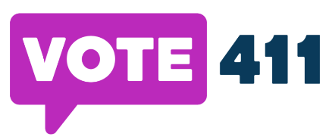
I will vote this Election Day to stand up for what matters most to me, my family and my community.

I, pledge to vote this year.
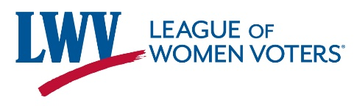
Please send me reminders about upcoming elections:
Email:
Cell:

I will vote this Election Day to stand up for what matters most to me, my family and my community.
I, pledge to vote this year.
Please send me reminders about upcoming elections:
Email:
Cell:

I will vote this Election Day to stand up for what matters most to me, my family and my community.
I, pledge to vote this year.
Please send me reminders about upcoming elections:
Email:
Cell:

