Print and cut out these cards to collect student information and remind them to vote.
-----------------------------------------------------------------------------------------------------------------------------------------
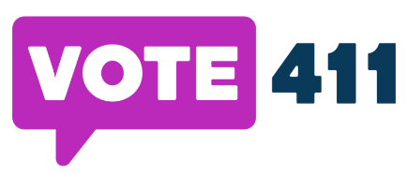
I will vote this Election Day to stand up for what matters most to me, my family, and my community.
I, , pledge to vote this year.
Please send me reminders about upcoming elections.
Email: _________________________________________
Cell: ___________________________________________
------------------------------------------------------------------------------------------------------------------------------------------
I will vote this Election Day to stand up for what matters most to me, my family, and my community.
I, , pledge to vote this year.
Please send me reminders about upcoming elections.
Email: _________________________________________
Cell: ___________________________________________
------------------------------------------------------------------------------------------------------------------------------------------
I will vote this Election Day to stand up for what matters most to me, my family, and my community.
I, , pledge to vote this year.
Please send me reminders about upcoming elections.
Email: _________________________________________
Cell: ___________________________________________
------------------------------------------------------------------------------------------------------------------------------------------
I will vote this Election Day to stand up for what matters most to me, my family, and my community.
I, , pledge to vote this year.
Please send me reminders about upcoming elections.
Email: _________________________________________
Cell: ___________________________________________
------------------------------------------------------------------------------------------------------------------------------------------
I will vote this Election Day to stand up for what matters most to me, my family, and my community.
I, , pledge to vote this year.
Please send me reminders about upcoming elections.
Email: _________________________________________
Cell: ___________________________________________
------------------------------------------------------------------------------------------------------------------------------------------

