Responding to the Lack of Election Funding in the Senate’s Stimulus Bill | Digital Toolkit
Adapted from Declaration for American Democracy toolkit
July 29, 2020

About
Months after passage of the House’s HEROES Act, which allocated $3.6 billion in funding for critical election reforms, the Senate’s proposed COVID relief package includes zero dollars for election assistance. This is unacceptable. The exclusion of election funding is forcing Americans to choose between their health and their vote this November - a choice no one should have to make. Use the resources below to make it clear to Congress that the American people demand a safe election.
Table of Contents
- Social Media Suggestion
- Key Talking Points
- Letter to the Editor Template
- Email Blast Template

Social Media Suggestion
Social Media
For Twitter and Facebook
Experts say we need $3.6 billion to fund 2020 elections. The proposed HEALS Act allocates $0. This is [unacceptable/intolerable/disgraceful/disastrous/appalling]. Without fully funded elections, millions of Americans must choose between their health & their right to vote.
Call your Senators: 1-888-415-4527
#ProtectOurVote

[+ Graphic that matches word included in language.]
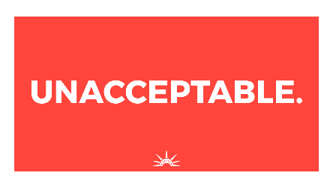  Download |   Download | 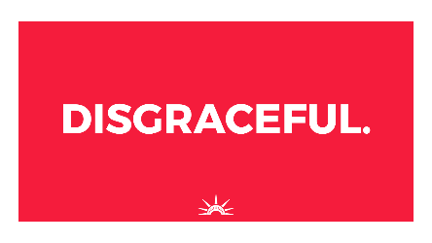  Download
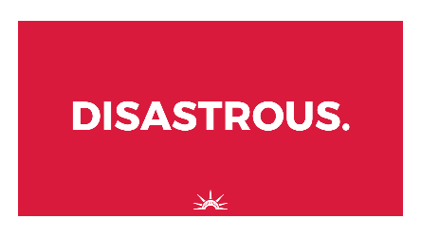  Download | 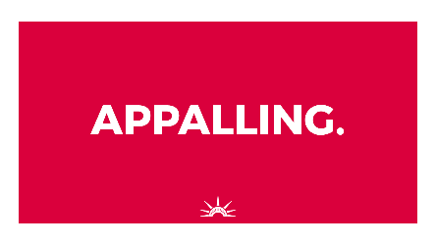  Download | 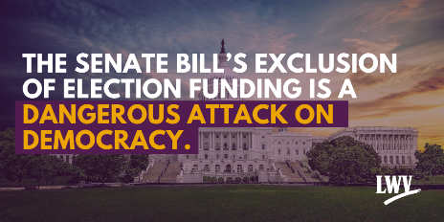  Download

Key Talking Points
Key Talking Points
1. The Senate’s exclusion of any election protection funding in the new COVID-19 stimulus bill will force Americans to choose between exercising their constitutional right to vote and safeguarding their health in this year’s elections.
- This move is a disgrace to our democracy and ignores the will of thousands of Americans who have already asked Congress to take action to protect our elections this fall.
- The Senate has the chance to reduce the risk of coronavirus for vulnerable groups such as seniors, BIPOC, and other at-risk people, by passing vital election reforms in the House-passed HEROES Act. These reforms, such as same day voter registration and expanded early voting, are especially critical for combating voter suppression in historically disenfranchised communities.
- The countdown clock is ticking. All Americans deserve equal access to the ballot box. The Senate must act now.

2. Congress needs to invest at least $4 billion to protect every vote and voter in America this year.
- Experts estimate that the reforms needed to secure our elections will require a $4 billion investment from Congress for states and precincts to carry out this year ($400 million of which has already been sent to states, without stringent enough requirements to protect voters everywhere).
- Here in [State], the funds would go far in ensuring we can [Insert details on reforms the funding would support such as “expand early voting,” etc.]

3. Money alone isn’t the solution. We need pro-safety and pro-voter policies to go hand-in-hand with election protection funding.
- There are many important reforms laid out in the HEROES Act that the Senate should adopt, but five key reforms would significantly boost access to the ballot and ensure [State] don’t have to choose between their health and their vote. These include:
  - Ensuring that [State] takes steps to protect the health and safety of poll workers and voters.
  - Expanding voter registration options such as online registration and same-day registration.
  - Requiring [State] to expand early voting to prevent lines and crowded polling places on Election Day, where people could be exposed to the coronavirus.
  - Enacting no-excuse postage-paid vote-by-mail as an option for every voter in [State] and across America.
  - Providing assistance at the polls for voters whose first language is not English, or voters with disabilities or other needs.
- The Wisconsin and Georgia primaries earlier this year illustrated what can go wrong when states don’t have safe voting protocols in place.
- Here in [State], we have already passed [information regarding election protection measures that already exist and those that are desperately needed].
  - [Add details]
  - [Add details]

4. More people safely accessing the polls in November does not give either party an upper hand.
- Research shows that it equally increases the number of voters from each political party.
- There is absolutely no evidence that measures to help people vote safely would increase the risk of election fraud. In the 2018 midterm election, more than 1 in 4 voters nationwide cast their votes by mail, and the results were fair and accurate.

Presser Template
Letter to the Editor Template
The Senate’s exclusion of any election protection funding in the new COVID-19 stimulus bill is a disgrace to our democracy and the will of thousands of Americans who have already asked Congress to take action to protect our elections this fall. The Senate leadership’s blatant disregard for the safety of voters, including here in [State], is appalling and forces Americans to choose between exercising their constitutional right to vote and safeguarding their health in this year’s elections.
States and cities desperately need an additional $3.6 billion in funding to protect voters’ health and voices at the ballot box. The needed funding was proposed in the House-passed HEROES Act, yet the Senate’s proposed HEALS Act provides exactly $0 in election funding.
[State] is running out of time to protect our health and constitutional right to vote, and the Senate is playing partisan politics with our democracy. In order to protect the health of [State] voters, we need [detail the types of voting reforms needed to protect voters’ health, safety, and right to vote—see talking points for more specifics].
Citizens across [State] and the U.S. need to make their voices heard by calling their Senators today to let them know that they must uphold their oath of office and defend the Constitution by ensuring that all Americans can vote safely this year.”

Blast Email Template
Email Blast Template
Subject Line: No Election Funding Forces Us to Risk Our Health to Vote
Preview Text: Senators want Americans to risk our lives to cast our vote.
<<First name>>,
Not only is our country facing an unprecedented public health and economic crisis, but our democracy is in crisis, too.
We have seen the devastating effect of voters forced to choose between their health and their vote in the disastrous Wisconsin and Georgia primaries, where thousands of voters had to wait in crowded lines for hours to cast their ballot.
Voters should not be forced to choose between our health and our freedom to vote.
The Senate just released a disgraceful proposal for the next stimulus bill that falls far short of the $3.6 billion needed to implement key reforms like vote-by-mail that experts have shown are needed for us to vote safely this year.
Instead of the needed $3.6 billion in election funding, the HEALS Act allocates $0.
Call your U.S. Senator at 888-415-4527 to demand that they pass $3.6 billion in funding and key requirements like vote-by-mail that will protect our health and ensure voters can safely cast their ballots.
Voting by mail or absentee ensures that voters can participate in our elections without having to venture outside during the pandemic. Expanded early voting will ensure that voters that need to vote in person won’t be faced with long lines and massive crowds.
But in order to win funding in time for the November election, we need to push back on this dreadfully inadequate proposal by demanding at least $3.6 billion in the upcoming COVID stimulus bill to fund these efforts.
Call your U.S. Senator at 888-415-4527 to demand that no Americans have to risk our health to cast our vote.
If we act together, we can make sure we can vote safely during COVID-19.
(Preferred Signature)

